Installation Instructions for Swivel Skid Wheels
(48-979011, 48-979012, 48-979013)
- Position a board as shown in Illustration 1. Place one end of board just behind rear wheels. Prop up the other end of board so board comes in contact with the lowest point of RV’s rear under carriage.

- Using board as reference, move skid wheel along the RV’s frame to find a point where the bottom of skid wheel is approximately 3” below board line. Mount wheel here.

- Weld mounting plates to frame is usually best. Sometimes additional reinforcement is required.

- Bolt casters to mounting plates using bolts and lock nuts provided.

- Grease casters and wheels before use.

- To mount second swivel skid wheel, repeat 1 thru 5 on other side of RV.

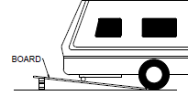
Illustration 1

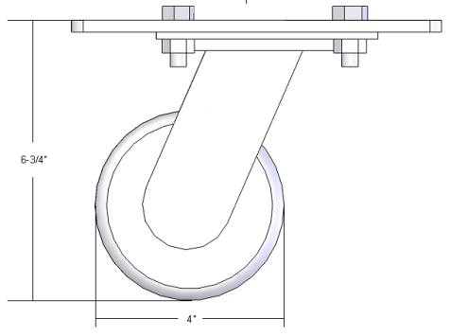
PN #48-979011 PN #48-979012 PN #48-979013
Skid Wheel 4” Travel Trailer Skid Wheel 5” Class C Skid Wheel 6” Class A
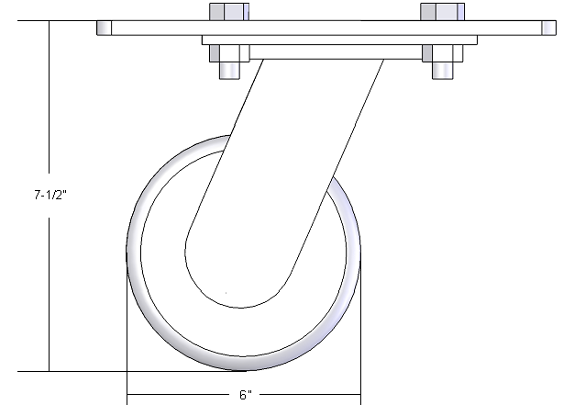
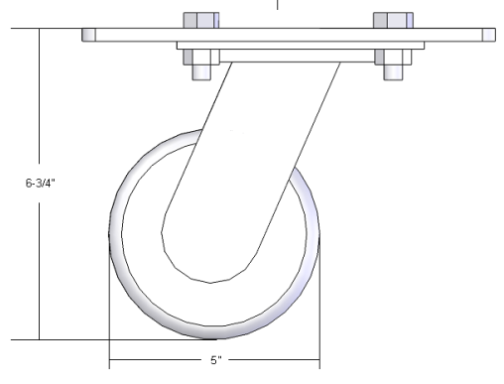

Alternative Mounting Method
The intended use of this product is to be installed onto the RV frame, as per the instructions on the reverse side. The enclosed hardware is for this type of installation.
However, some users prefer to mount skid wheels onto the hitch bar as shown in figure “B”. THE MOUNTING METHOD IN FIGURE “B” IS NOT RECOMMENDED AND WILL VOID THE WARRANTY. If the mounting plate is installed incorrectly (on top of the hitch bar), the top plate of the caster will bend causing bearing failure.
To mount skid wheels to your hitch, provided the RV has sufficient ground clearance, refer to figure “A” for correct mounting instructions. The mounting plate should position between the caster plate and the hitch bar, NOT on top of the hitch bar. Four “U” bolts for a 2 ½” square hitch bar are not included.
Parts List
No. | 4" |  | 5" |  | 6"
 | Name | QTY | Name | QTY | Name | QTY
1 | 4" Skid Wheels-Travel Trailer | 2 | 5" Skid Wheels-Class C Swivel | 2 | 6" Skid Wheels-Class A Swivel | 2
2 | mounting plate | 2 | mounting plate | 2 | mounting plate | 2
3 | 3/8" lock nuts | 8 | 1/2" lock nuts | 12 | 1/2" lock nuts | 12
4 | 3/8-16 X 1" bolts | 8 | 1/2-11 X 1 1/4" bolts | 12 | 1/2-11 X 1 1/4" bolts | 12
5 | 1/2" lock nuts | 4
6 | 1/2-11 X 1 1/4" bolts | 4

